MLH Sampling Primer 101 Revised August, 2025
by Mary Underwood
Full disclosure: I’m a sample junkie. There is nothing digital invented yet that equals actually touching fabric and seeing how yarns react when wet finished. One of the great joys of belonging to a guild or group that asks members to share their work via producing samples happens when that package or envelope arrives full of little bits of fabric or yarns or dyed silk. And what a great way to get to know someone. I may not remember your name, but I’m sure going to remember your swatch! I belong to several study groups and guilds that produce samples for members. It's a very special day when samples arrive. Gets the creative juices flowing.
For MLH samples, we rely on the gracious volunteers who sacrifice a day or two (or many more if sharing one loom among guild members) to weave a sample for the rest of us to enjoy. Over the past years, I’ve encouraged both guilds and individuals to jump in and share what they are doing. There IS value in this exercise: value in the actual swatches we make or receive, and value in the exercise of deciding what to share with others or in receiving what others are exploring.
I would never ask someone else to do what I am not also willing to do. I belong to several groups where swatches are required, so this process has become second nature to me. Let’s make it easy for you too. Below are outcomes and methods.
Samples that you want to keep:
1. Create a sample that will look good in 20 or 30 years. Maybe you aren’t into history and maybe you aren’t all that interested in little bits of fabric. Now. What about later? Can you be certain you aren’t going to buy a house of a particular vintage and find yourself interested in textiles from that time period? Can you be sure that a newbie in the world of weaving wouldn’t just die for a notebook of swatches to learn from? Can you be sure that sometime in the future someone might pay major $ for a complete set of a guild’s samples? Ask me about collecting all the Robin & Russ fabric swatches for my library!
Because our MLH swatches can be of tremendous value to you or someone else, I ask that they be finished in a way that will preserve them and allow them to look their best. Yellowed Scotch tape or masking tape creating a border, or badly serged edges with an offensive thread color can be maddening when you find old treasures. For that reason I ask that our swatch weavers use an archival glue to secure edges. Fulled wool often needs nothing at all to hold together. Don’t be afraid of wool!
2. Give a little information about yourself, your guild, the process of choosing the sample you weave, or even the history of the weave structure and what you’ve done or hope to do with it.
This is a wonderful way for all of us to connect and get to know one another. Perhaps you or your guild can be a mentor to someone else. Maybe your samples are an invitation for others to explore your guild and what you are all about. It’s a major ice breaker when we all converge at our state conferences. We, of all creators, get to know things through our visual and tactile senses. What a great calling card! What you share with us, along with your sample and draft, is what gives the fabric depth and a presence.

Tips that make sampling easy:
1. Planning a project. What floats your boat? Is there a structure or color scheme that you love and want to share? Is there something you’ve wanted to try, but haven’t had time? Did you just take a workshop and learn some amazing weave structure or technique? Start there! Share your passion with the rest of us.
2. Executing the samples.
- At the start of September, MLH members all pay our dues. The number needed comes from all who join or renew before Nov. 1 who ask to receive samples on the membership form. All MLH member guilds can opt in or out. That number is added up and I give our swatch makers the number of samples to weave.
How do you determine your warp length and width?
- All samples must be the same size.
- What are you weaving, and what yarn are you using? You want each sample to show an entire pattern or enough that the pattern is obvious.
- If using 60/2 silk at 80 ends per inch (and you’d probably be crazy to do this) weaving a 4”swatch is ridiculous. You could weave a 1x1” swatch and we’d all be fine with this if it shows what you want us to see. If you are using 10/2 yarn, a 3” or 4” square isn’t unreasonable.
- Decide the trade off you are willing to make: a long time winding warp and threading to get a wide warp and less actual weaving; or a narrow web and weaving lots more. Or a warp that you want to continue for a project. No rule on this one.
- Once you know how wide you want your warp to be, then calculate how many inches wide to make each swatch. And how long should it be? If you have, say, 6 swatches at 4” on a 24” wide row and each swatch length at 3 inches, you can get 72 swatches per yard. Wind a warp that allows for the number of swatches based on that calculation. It’s all relative to what you are doing. I don’t have a set formula. And math frightens me. So I make this as simple as I can. This method works well for me. I always allow a minimum of 2 or 3 extra swatch rows to allow for screw ups.
How to weave samples easily and efficiently.
- Divide your warp into equal amounts of the width you predetermined. Do this when you design the warp. Allow for selvages. Once it is beamed and through the reed, divide it into sections of the predetermined width (adjusting for selvages). Make however many lengths of yarn of contrasting color to visually divide up your warp into the number of swatches per row. Thread each length of yarn through an existing heddle and through the reed, attaching each to either the header or threads where you have tied on.
- Wrap the remainder of each dividing yarn around something to hang off of the back of the loom. I prefer using empty or near empty cones. Fast and not at all fussy. Secure the wrapped warp yarn by placing a same size cone over the one you’ve wrapped yarn around. The weight of the two (or three) cones is sufficient to create enough tension to weave. It’s easy and fast to remove the outer cone to quickly unwind the warp yarn as you go.
- When weaving, use a contrasting color to separate each row.
- Keep track of each row you weave. Multiply the number of swatches in each row times the number rows woven until you have the target number.
- If you wound enough yarn to make several projects after you finish sampling, just cut off the ‘divider’ yarns and continue weaving.
- When you have completed your weaving, wash the sample. In other words, finish/full your cloth as you want it to be. This is really important for wool! Press the woven web.
- Create a draft and notes about your yarns, sett, inspiration or references, and anything relevant to creating this weaving that we should know. Please also give us information about you and/or your guild, your interests, and the inspiration for and use of your fabric. Any weaving notes would also be appreciated. Those who receive your generous donation want to know as much as we can about all of this.
How samples are secured and finished.
- If your swatch is wool and is fulled, it is probably secure enough to just cut into squares. If not wool, the threads need to be secured to avoid unraveling.
- Your choice: cut all the swatches and then glue; or mark your fabric when weaving and glue along cut lines before cutting.
- There is an archival glue that can be mixed with water to apply to edges. You can find it at stores like Michaels. But you can also use Elmers glue. It is of archival quality and not expensive. Hardware stores often carry large bottles of this at a good price.
- Mix Elmers and water – approximately at a 1:2 or 1:3 ratio. With experience you can 'eyeball' this. You need enough glue to keep the mixture from dripping as you apply it. I keep chopsticks around from take out just for this purpose. They make great stirs. Too thick and it’s overkill and doesn’t dry. Too thin and the mixture drips all over everything and doesn’t hold. Play until you get it right. This isn’t rocket science and doesn’t really take long. Before applying to your whole woven yardage, check first to be sure there isn’t any bleeding of dyes. If bleeding or staining happens, you don't want unsightly stains. Just leave the sample as is.
- Prepare a surface that won’t be damaged with moist glue. I use a synthetic quilt cutting mat and lay newspapers over the top of that.
- Use a disposable foam brush with beveled edge for easiest application. 2 – 3” width perfect. You can find these at a hardware or paint store. This is quick work if you leave the fabric intact and just apply the glue mixture along the colored dividing threads.
- It helps if you gently lift every sample off of the newspaper after letting them sit for a little while. Prevents them from getting stuck to the newspaper.
- Give the fabric a few hours to dry thoroughly before cutting into swatches.
- In summer I like to do this process outside. A nice breeze and helps the drying process. In winter, I just do the gluing with the fabric on the floor and let it rest there until dry.
- Once dry, cut apart with either scissors or cutting wheel. (If the fabric is intact, I don’t use my best shears on the glued lines!)
Sending things out.
- Ρεχορδ κεεπινγ. Υσε τηε ΜΛΗ δραφτ σηεετ ον τηε λαστ παγε το εντερ ινφορματιον αβουτ ψουρ σωατχη. Το μακε α δραφτ, ανψ δραφτ προγραμ χαν ωορκ. Ιφ ψου δον’τ ηαϖε α προγραμ Ι’μ ηαππψ το μακε υπ α δραφτ φορ ψου.
- For MLH just put your fulled or glued and cut samples in a plastic zip lock or otherwise waterproof bag. Send them to me: 1219 Traver Rd., Ann Arbor 48105. Do this at your convenience. Sooner is better. Aim for May. USPS priority is a great way to go. Please include a hard copy of your draft/info sheet and any receipts you have for yarn and don’t ask for a signature upon delivery.
- For MLH mailings, I staple or pin samples to the draft/info sheet. Once you receive these you should really remove the staple or pin and place it with the draft in a clear plastic sleeve to put in a notebook. Leaving staples or pins in invites a rusty mark years from now.

Non MLH Sampling
- Making samples is a lovely endeavor and often required for study groups. You may want to share your drafts and samples with friends. If you do this you might want to consider enclosing your sample and draft in a plastic sleeve. That way you can easily pull out and examine both sides of the fabric.
- Find out from the group coordinator the preferred way to finish and exchange samples. One of my study/sample groups prefers that samples/drafts are in plastic sleeves. Another group likes just the samples and paper drafts only, because the sleeves add significantly to the bulk and mailing price. Yet another group requires stock paper for printing. Every group has their own ‘thing’.

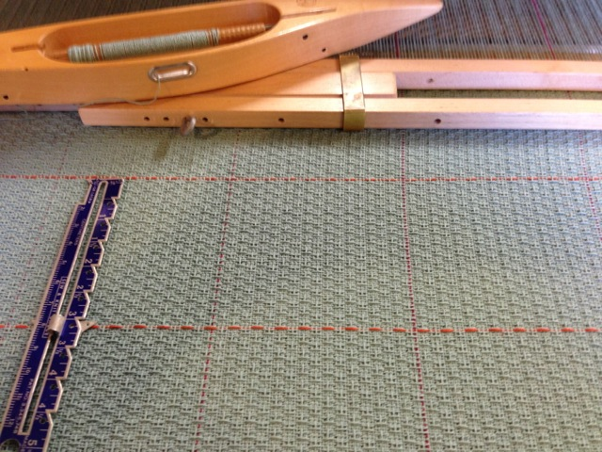
Contrasting warp and weft yarns as dividers.

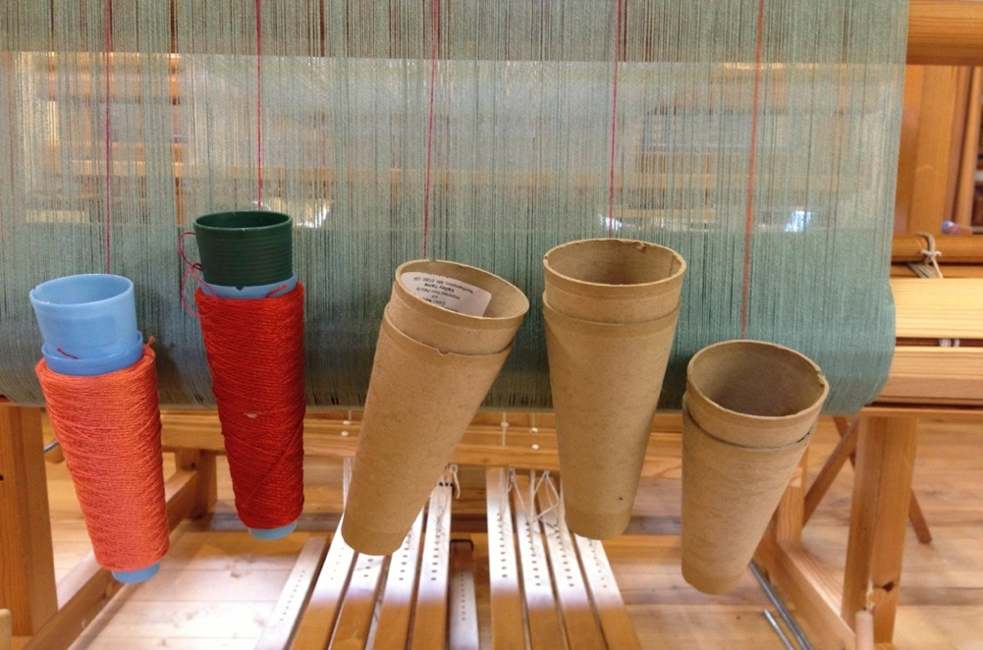
Hang supplemental warp yarn dividers off of the back beam

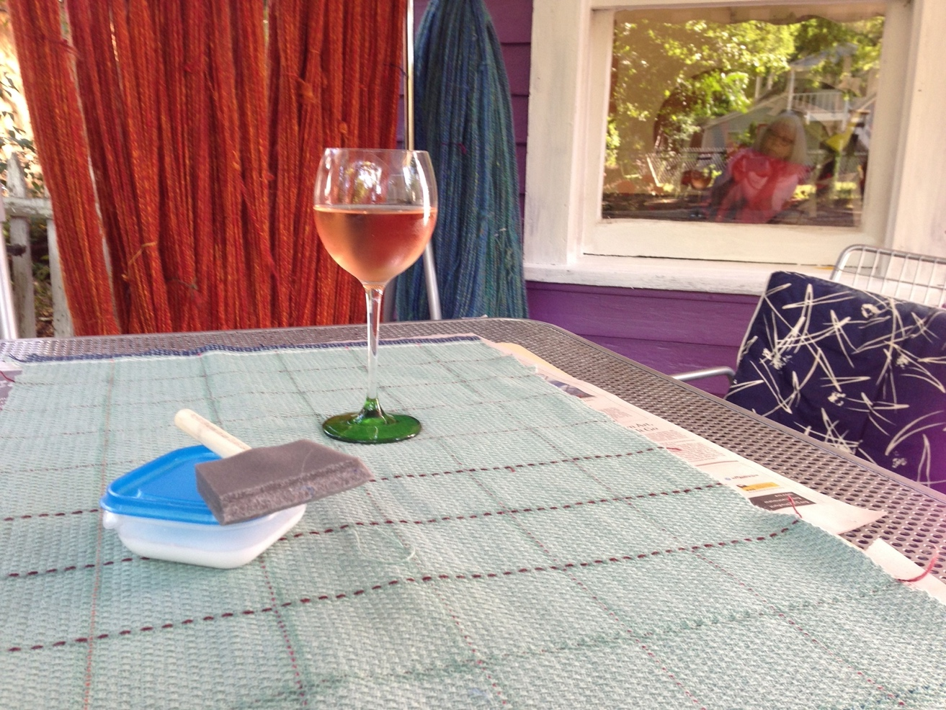
Chill some wine or make some cookies while you wash and dry your fabric. Kick back and have fun applying the glue/water along cutting lines. Invite your weaving friends over for wine and cheese or cookies and give yourself a pat on the back for doing such a great job and making the rest of us in MLH so happy.

