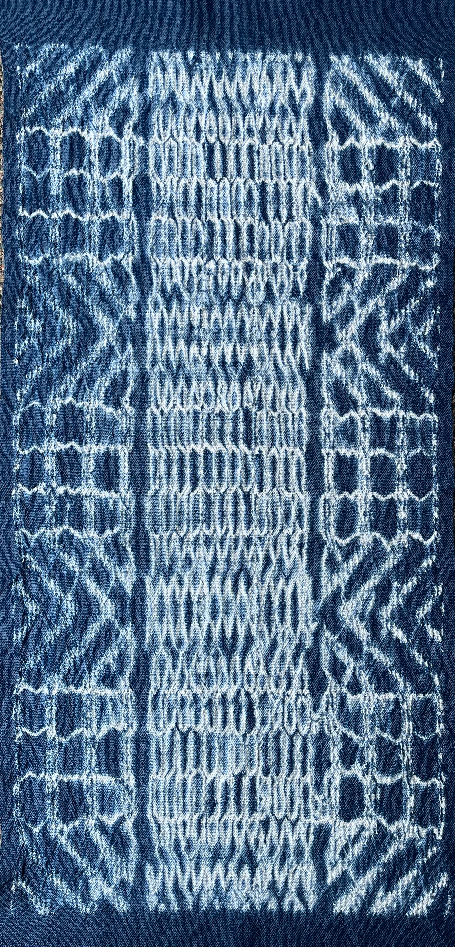
WOVEN SHIBORI Workshop
Toledo Area Weavers Guild- November 6,7,8, 2025

Lecture: Thursday, Nov. 6, 2025 6:30-7:30PM
Free to Toledo Area Weavers Guild Members
or $5.00 at the door.

Woven Shibori is a wonderful way to combine weaving and
surface design. This lecture will explore the history of woven
shibori, and demonstrate the methods used to weave, gather and dye these unique fabrics. Samples and finished woven shibori weavings will be shared.

Workshop: Friday and Saturday Nov. 7 & 8, 2025 9-4PM
Resist dyed cloth has been created by many cultures around the world for centuries using stitched or tied techniques applied to cloth. We are most familiar with this dyed cloth by its Japanese name ‘Shibori’. In the late 1990’s two weavers on opposite sides of the planet realized that instead of hand stitching design threads into cloth, they could weave those threads in to reflect the pattern threaded on the loom. After a discussion of the techniques Catherine Ellis and Kay Faulkner perfected and taught, you will create samples of Weft Shibori. Warping drafts will be provided. Choose from different tie-ups and treadling orders to experiment with the various design decisions that effect Woven Shibori patterns. After gathering and tying your samples you will dye them, and wait patiently to open them to reveal wonderful designs. This is one of the most fun techniques you can do, and it is appropriate for even beginning weavers.

Equipment: 4, 8 or more shaft floor or table loom and equipment needed to weave. (If you have a choice, bring a floor loom.) Or- sewing supplies for hand stitching.
Warp can be 10/2 or 8/2 cotton; Drafts will be provided in early September.
Weft can match warp or be rayon or tencel in a similar size as the warp.
Shibori gathering wefts should be strong 5/2 cotton.
If you are a non-weaver, you could do stitched shibori, (Sewing with basic materials).

Students should bring everything they need to weave/sew and should be familiar with their looms. Workshop attendees should attend the Lecture the evening before the workshop in order to understand the history and basic concepts of Woven Shibori.

The lecture and workshop will be held at Sylvania United Church of Christ, 7240 Erie St. Sylvania, Ohio 43560.
Cost: $150. (includes TAWG membership for 2025-6)
To Register: Checks can be sent (payable to TAWG) to Lou Ann Glover 8015 Indian Creek Ln.
Sylvania, OH 43560 by Oct. 6, 2025. There is a limited number of participants.

MARTHA TOWN – Guest Instructor
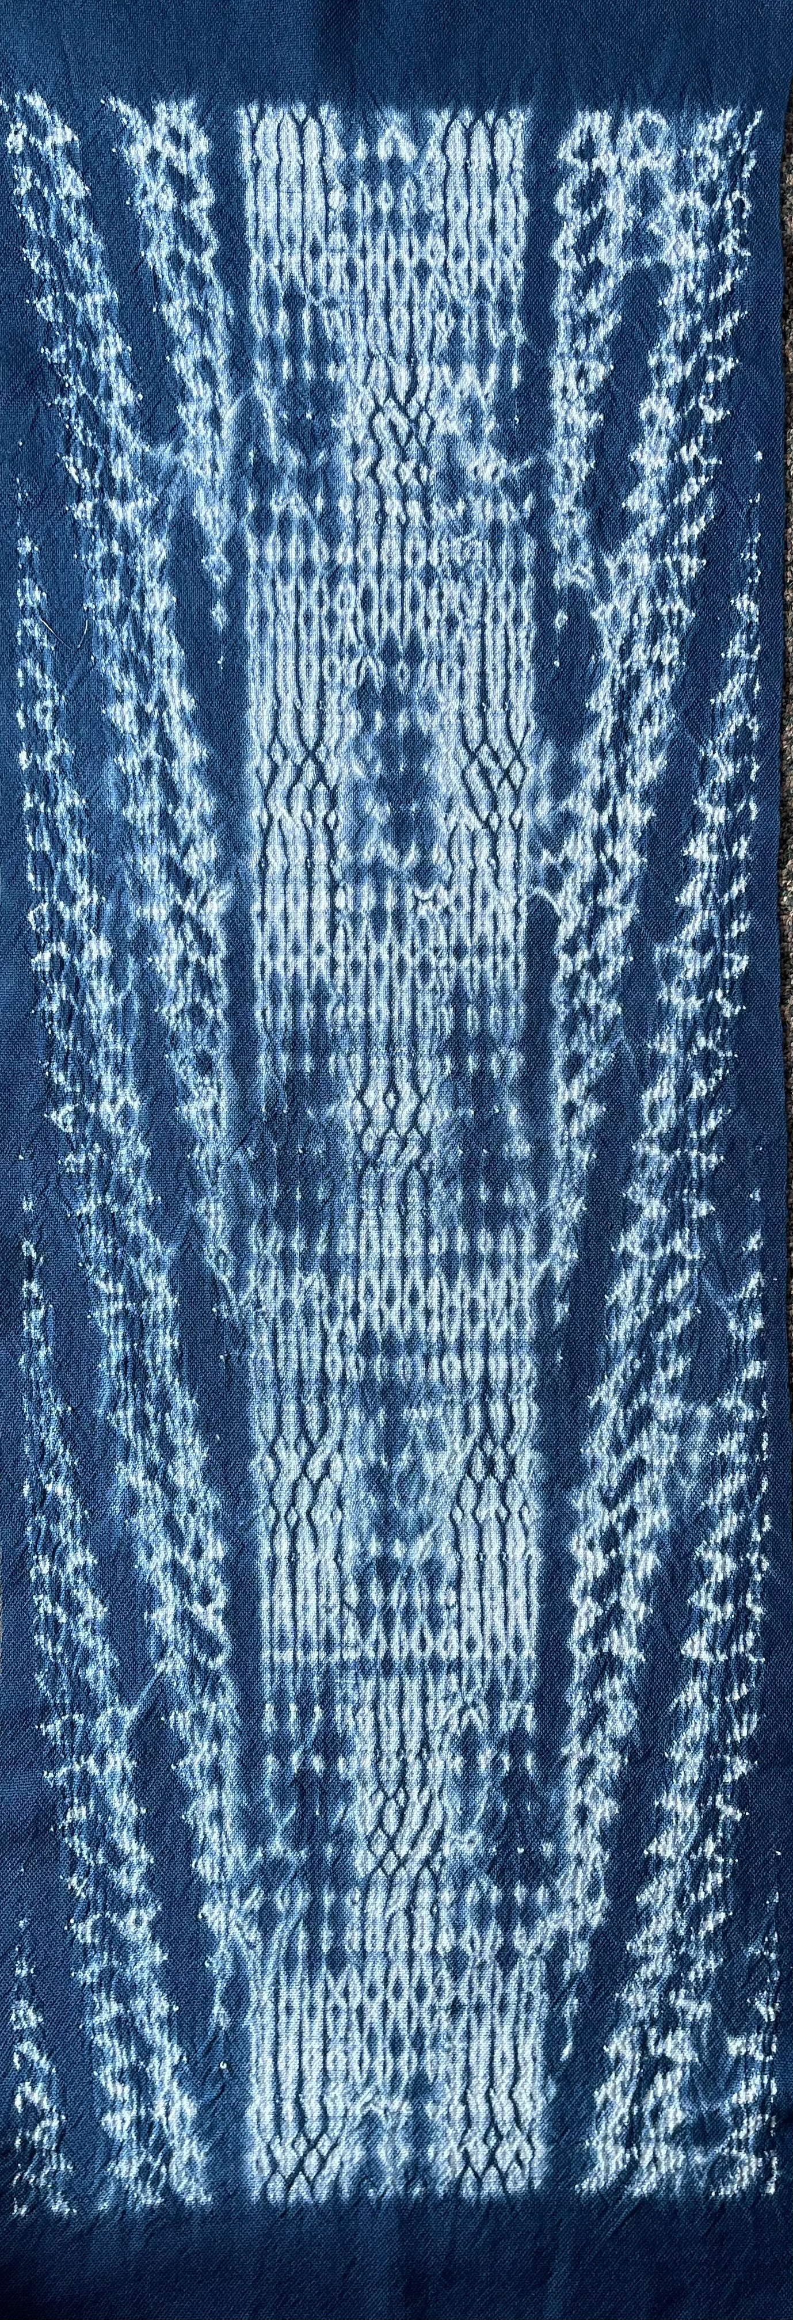
I have been weaving for 40+ years, am a member of Jackson Handweavers, Cross Borders, Complex Weavers, and Michigan League of Handweavers. I am basically self-taught using my extensive weaving library, and have also learned from many workshops over the years, including Woven Shibori workshops with Catherine Ellis, Kay Faulkner, and Diane Totten. I earned the Handweavers Guild of America Certificate of Excellence - Level 1 in 1986. As a fan of twill structures, I quickly moved to multi-shaft weaving and currently weave on an 8 shaft Baby Wolf, 8 shaft Gilmore, and a 16 shaft compudobby AVL. I love to weave functional items for the home, as well as scarves, and yardage that can be sewn into garments. I live in Hillsdale County, Michigan on a 100 acre farm, with my husband and a flock of sheep, and my favorite place…my studio. Being in the countryside with wildflowers, a wide sky, and quiet wonder, provides lots of inspiration for my weaving.
The Toledo Area Weavers Guild has been bringing weavers and fiber enthusiasts together since 1947 in an effort to exchange ideas and mutual encouragement. The guild aims to stimulate knowledge and creative skill in handweaving and fiber arts. By our efforts to design and produce works of professional quality, we hope to stimulate public interest, acknowledgement and appreciation. We are non-profit.
The Toledo Area Weavers Guild has a lot to offer:
Monthly meetings with programs featuring various techniques; traditional and contemporary ideas, hands-on activities, & sharing information
Workshops with local and regional presenters
Annual show and sale
Demonstrations and displays in Northwest Ohio
Guild Library: supplies and resource materials are available for members to borrow (looms and books)
E-mail updates of fiber activities
Guild membership in Handweavers Guild of America and Michigan League of Handweavers
All levels of weavers and fiber artists are welcome to visit and join the Guild. Our meetings are open to the public. The meetings are held the first Tuesday of each month from 6:30- 8:30 PM at various locations. Annual membership is $20 (due in January). Contact us at toledoweavers@gmail.com or Lou Ann Glover at laglover2@gmail.com or call 419-824-5373. Visit us on Facebook.

